CloudGuardian
Azure Terraform Setup Guide
Setup Guide
Deploying the CloudGuardian Terraform Project
File by file, then step by step — a complete walkthrough for a free-tier Azure account, written for someone with zero prior command-line experience. This edition adds the two steps that complete Week 1 of the capstone: documenting the secure baseline with Prowler, and introducing the controlled set of misconfigurations.
Quick clarification before we start: Terraform doesn’t run these files one at a time — it reads every .tf file in the folder together as a single combined blueprint, and works out the correct build order itself (for example, it always knows to create the Resource Group before anything that needs to live inside it). The “one after another” that matters is the order you read them in to understand the design (Part 1), and the order of the commands you’ll type (Part 2) — not the files themselves. You’ll only ever run the commands against the whole folder at once.

Table of Contents
If the table below looks empty or out of date, right-click it and choose “Update Field,” or press Ctrl+A then F9.
Table of Contents 2
Part 1 — A Quick Tour of the Project Files 4
File 1: versions.tf — the version label 4
File 2: providers.tf — connecting to Azure 4
File 3: variables.tf — the settings panel (and the misconfig switches) 4
File 4: locals.tf — naming everything consistently 4
File 5: main.tf — the foundation 5
File 6: network.tf — the streets and the firewall 5
File 7: compute.tf — the web tier 5
File 8: database.tf — the database tier 5
File 9: storage.tf — the storage tier 6
File 10: outputs.tf — what Terraform tells you afterwards 6
File 11: iam_and_extra_misconfigs.tf — the IAM additions 6
Three more files in the zip (not .tf, but worth knowing about) 7
Part 2 — Step by Step: From Zero to Running Infrastructure 8
Before You Start 8
Step 1 — Install the Three Tools You Need 8
Step 2 — Sign In to Azure From Your Computer 8
Step 3 — Create an SSH Key (Your “Password” for the Virtual Machine) 9
Step 4 — Find Your Public IP Address 9
Step 5 — Unzip the Project 9
Step 6 — Fill in Your Personal Settings 10
Step 7 — Set Your Database Password (the Safe Way) 10
Step 8 — Initialize Terraform 10
Step 9 — Preview What Will Be Built 10
Step 10 — Build It for Real 11
Step 11 — Confirm It Actually Worked 11
Step 12 — Document Your Baseline Security Posture with Prowler (Week 1, Task 2) 11
Step 13 — Introduce the Controlled Misconfiguration Set (Week 1, Task 3) 13
Step 14 — Shut It Down When You’re Done for the Day 17
Troubleshooting Common Errors 19
Quick Command Cheat Sheet 21

Part 1 — A Quick Tour of the Project Files
Eleven .tf files make up this project — the original ten plus one new addition (File 11) for the IAM-related misconfigurations. Here they are in the order it makes sense to read them — roughly “foundation first, then network, then each tier, then what you see at the end, then the IAM extras.”

File 1: versions.tf — the version label
File 1 — Makes sure everyone runs compatible versions
Think of this as the “system requirements” label on a software box. It tells Terraform:
- the minimum version of Terraform itself this project needs
- which providers (plugins that know how to talk to Azure) to download, and which version range of each
You won’t edit this file. It just runs quietly in the background every time you type a Terraform command.

File 2: providers.tf — connecting to Azure
File 2 — Configures how Terraform talks to your Azure account
This file is short on purpose. It doesn’t contain any password or key — Terraform automatically reuses the login session you create with az login in Part 2, Step 2. This file just sets one safety behavior (letting terraform destroy clean up the resource group even if something inside it wasn’t created by Terraform).
You won’t edit this file.

File 3: variables.tf — the settings panel (and the misconfig switches)
File 3 — Every adjustable setting in the project, in one place
This is the longest file, and the most important one to understand — though you still won’t edit it directly. It declares every value that can be customized: your region, your VM size, your SSH key, your IP address, your SQL password, and eighteen true/false “misconfiguration toggle” switches, each defaulting to the secure setting.
You’ll set the values for some of these in terraform.tfvars (Part 2, Step 6) — think of variables.tf as the form’s blank template, and terraform.tfvars as the filled-in form.

File 4: locals.tf — naming everything consistently
File 4 — Generates consistent names and one random unique suffix
Builds predictable names like rg-cloudguardian-lab and vnet-cloudguardian-lab for every resource, so nothing clashes and everything is easy to find in the Azure Portal. It also generates one random 5-character suffix, used only where Azure requires a name to be unique across the entire planet (your storage account and SQL server) — not just unique within your account.
You won’t edit this file.

File 5: main.tf — the foundation
File 5 — Resource Group + Log Analytics Workspace
Creates the two things everything else lives inside or reports back to:
- Resource Group — a folder in Azure that holds every other resource this project creates, so you can find, manage, or delete everything as one unit
- Log Analytics Workspace — the destination logs get sent to. This exists specifically to address the “missing logging” control from your capstone’s problem statement
Misconfig toggle lives here: misconfig_short_log_retention — shortens the workspace’s log retention from 30 days down to 7.

File 6: network.tf — the streets and the firewall
File 6 — Virtual Network, two subnets, and the Network Security Group
Builds the networking layer your other resources sit inside:
- a Virtual Network (your own private address space in Azure)
- a web subnet and a data subnet — the “two subnets” your capstone brief asks for
- a Network Security Group (a firewall) attached to the web subnet, with rules for HTTPS, HTTP, and SSH
Misconfig toggle lives here: misconfig_ssh_open_to_internet — flips the SSH rule from “only my IP” to “anyone on the internet.” misconfig_vm_remove_nsg_association (detaches the NSG from the web subnet entirely) and misconfig_nsg_allow_any_any (adds a standalone any-protocol/any-port/any-source rule) also live here.

File 7: compute.tf — the web tier
File 7 — Public IP, network card, and the virtual machine
Builds the web tier: a public IP address, a network interface card, and an Ubuntu Linux virtual machine. A small startup script installs nginx (a basic web server) so you have something to actually see in a browser once it’s running. The VM also carries a system-assigned managed identity — having an identity isn’t itself a misconfig; what gets granted to it is (see File 11).
Misconfig toggle lives here: misconfig_vm_allow_password_auth — flips the VM from “key-only SSH login” to “also accepts a password.”

File 8: database.tf — the database tier
File 8 — Azure SQL server + database, and firewall rules
Builds the “small RDS or SQL instance” your brief asks for: an Azure SQL logical server, a Basic-tier database on it (cheap, ~2GB), and firewall rules controlling exactly which IP addresses are allowed to connect.
Misconfig toggle lives here: misconfig_sql_allow_all_ips — adds a firewall rule spanning the entire internet (0.0.0.0–255.255.255.255), i.e. “database open to the world.” misconfig_sql_disable_tde (turns off Transparent Data Encryption) and misconfig_sql_min_tls_version (lowers the minimum TLS version to 1.0) also live here.

File 9: storage.tf — the storage tier
File 9 — Storage Account + container, plus logging wiring
Builds the “object-storage bucket” your brief asks for: a Storage Account and a blob container inside it (Azure’s equivalent of an S3 bucket). It also wires up diagnostic logging from the storage account and the SQL database into the Log Analytics Workspace from File 5.
Misconfig toggle lives here: misconfig_storage_public_container (makes the container world-readable), misconfig_storage_allow_public_network_access (opens the storage account to any network), misconfig_disable_storage_logging (skips the storage logging wiring), misconfig_disable_sql_logging (skips the SQL diagnostic setting independently), misconfig_storage_allow_shared_key_access, misconfig_storage_disable_secure_transfer, misconfig_storage_min_tls_version, and misconfig_storage_cors_allow_all.

File 10: outputs.tf — what Terraform tells you afterwards
File 10 — The values printed to your screen after apply finishes
Doesn’t build anything — it just decides what useful information to print back to you once everything above has been created: your VM’s public IP, a ready-made SSH command, your SQL server’s address, your storage account’s name, and a one-line true/false summary of which misconfig toggles are currently switched on.

File 11: iam_and_extra_misconfigs.tf — the IAM additions
File 11 — Two role assignments that exist only when toggled on
New in this edition, added via the patch in Step 13a. Declares one data source (your own identity, via data.azurerm_client_config) and two azurerm_role_assignment resources — both with count = 0 by default, meaning they don’t exist at all until you flip the corresponding toggle.
Misconfig toggle lives here: misconfig_iam_owner_role_at_rg_scope (assigns Owner at the Resource Group instead of a scoped role) and misconfig_vm_identity_over_privileged (grants the web VM’s own managed identity Contributor at the subscription scope).

Three more files in the zip (not .tf, but worth knowing about)
- terraform.tfvars.example — a template for your personal settings. In Part 2 you’ll copy this to a real file called terraform.tfvars and fill in your own IP address and SSH key. This is the only file you’ll actually type your own values into.
- .gitignore — if you ever upload this project to GitHub, this tells Git to never upload your real terraform.tfvars, your state file, or any key files. Doesn’t affect how Terraform runs.
- README.md — background reference: cost notes, extra misconfiguration ideas to reach your rubric’s 8–12 count, and pointers to related repos. Not required reading to get up and running.

Part 2 — Step by Step: From Zero to Running Infrastructure
Now that you know what each file does, here’s the actual procedure. Follow it top to bottom, in order. Total time: roughly 60–75 minutes the first time through, including the new Prowler and misconfiguration steps. Commands are written for Windows (PowerShell); Mac/Linux notes are called out separately where they differ.

Before You Start
☐ An Azure account with the free account or student credits activated (if not: go to azure.microsoft.com/free and sign up — about 10 minutes)
☐ About 60 minutes of uninterrupted time
☐ The azure-3tier-terraform.zip file from earlier in this chat, downloaded somewhere you can find it (e.g. Downloads)

Step 1 — Install the Three Tools You Need
Open PowerShell (search for it in the Start menu) and run these one at a time.
1a. Azure CLI (lets your computer talk to Azure)
winget install Microsoft.AzureCLI
Note: if winget says “command not found,” download the installer instead from aka.ms/installazurecliwindows and run it like any normal .exe.
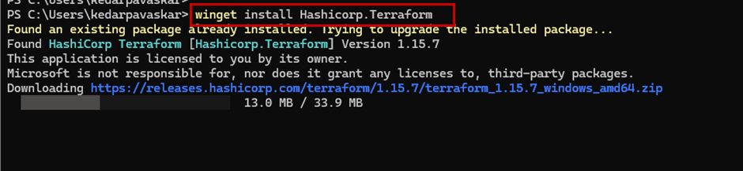
1b. Terraform (the tool that actually builds the infrastructure)
winget install Hashicorp.Terraform
Note: if that fails, go to developer.hashicorp.com/terraform/install, download the Windows zip, extract it, and place terraform.exe somewhere like C:\terraform\ — then add that folder to your PATH (search “Edit environment variables” in the Start menu → Environment Variables → Path → New → paste C:\terraform).
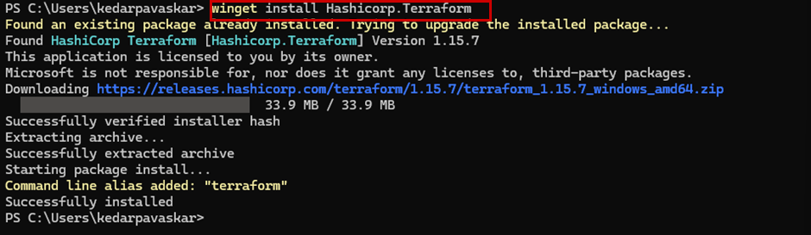
Close and reopen PowerShell, then check both installed correctly:
az --version
terraform --version
Each should print a version number, not an error. If either says “not recognized,” close PowerShell completely and open a fresh one (this refreshes PATH) before trying again.
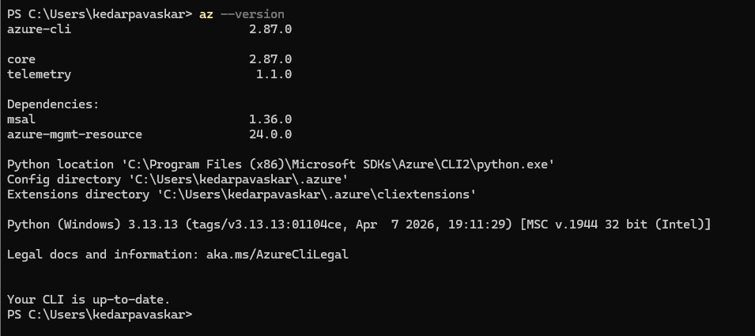
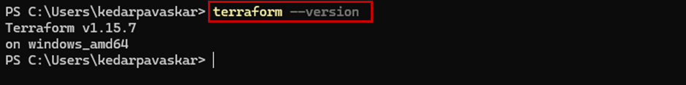
Mac: brew install azure-cli terraform
Linux (Ubuntu/Debian): see learn.microsoft.com/cli/azure/install-azure-cli-linux for Azure CLI, and developer.hashicorp.com/terraform/install for Terraform.

Step 2 — Sign In to Azure From Your Computer
az login
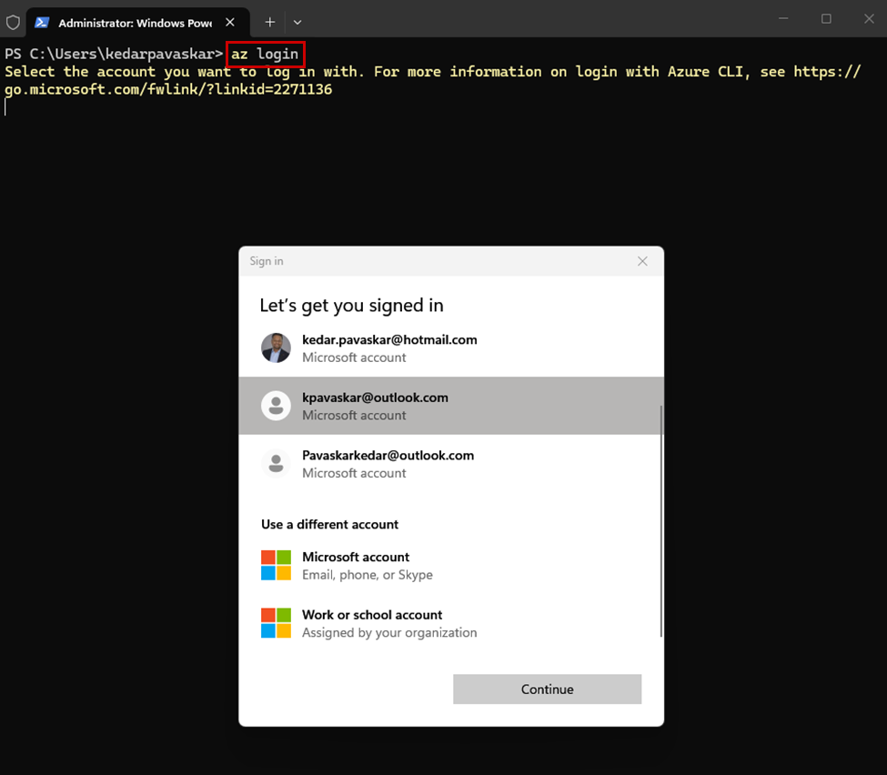
A browser window pops up — log in with the same email you used for your Azure free account. Once you see “Login succeeded” and a block of JSON in PowerShell, you’re connected.
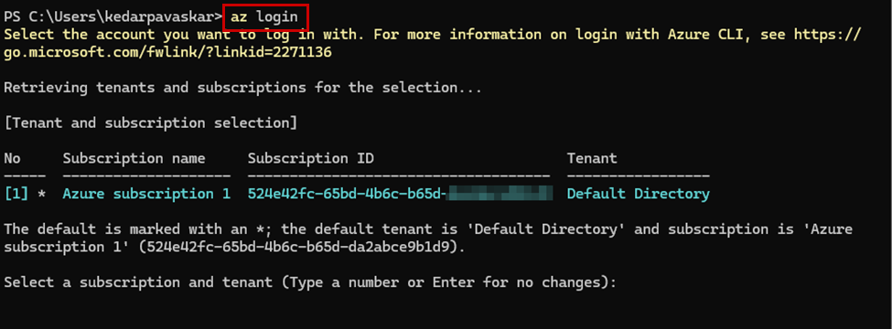
If you have more than one subscription, list them and confirm you’re on the right one:
az account list --output table
az account show --output table
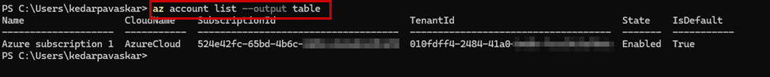
If the wrong one is active, switch with:
az account set --subscription "Your Subscription Name"

Step 3 — Create an SSH Key (Your “Password” for the Virtual Machine)
Check if you already have one:
Test-Path $env:USERPROFILE\.ssh\id_rsa.pub
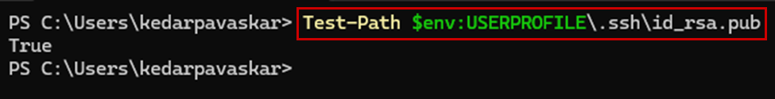
If that says True, skip ahead — you already have a key. If False, create one:
ssh-keygen -t rsa -b 4096
Press Enter at every prompt (accept all defaults, no passphrase needed for this lab). This creates two files in C:\Users\<you>\.ssh\:
- id_rsa — your private key. Never share this, never paste it anywhere.
- id_rsa.pub — your public key. This one is safe to share/paste; it’s what we’ll give to the VM.
View your public key so you can copy it in a later step:
Get-Content $env:USERPROFILE\.ssh\id_rsa.pub
Copy the entire line it prints (starts with ssh-rsa AAAA...).
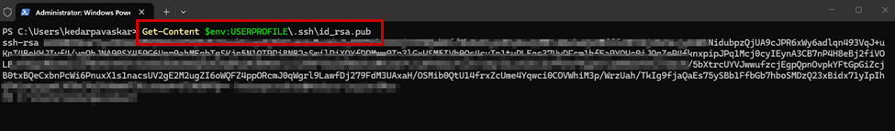

Step 4 — Find Your Public IP Address
Open a browser and go to: https://ifconfig.me
It shows a number like 203.0.113.45. Write it down — you’ll use it as 203.0.113.45/32 (the /32 means “exactly this one address”).
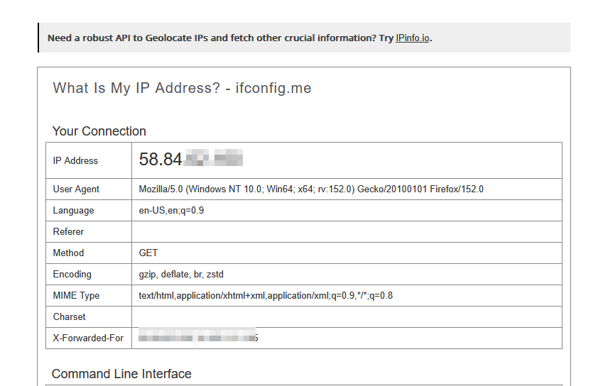
Heads up: if your internet connection changes later (different Wi-Fi, mobile hotspot, VPN on/off), this number changes too, and you’ll need to update it and re-run terraform apply — see Troubleshooting at the end.

Step 5 — Unzip the Project
In File Explorer, find azure-3tier-terraform.zip (probably in Downloads), right-click → Extract All. Choose a simple destination like C:\projects\ so the path is easy to type.
Then in PowerShell, move into that folder:
cd C:\projects\azure-3tier-terraform
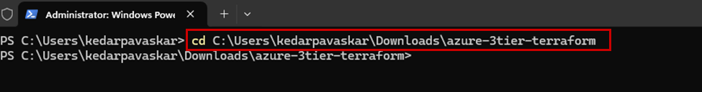
Confirm you’re in the right place — you should see the 11 files from Part 1 (including iam_and_extra_misconfigs.tf if you’ve already applied the patch from Step 13a), plus the three supporting files:
dir

Step 6 — Fill in Your Personal Settings
Copy the example settings file to a real one:
Copy-Item terraform.tfvars.example terraform.tfvars
Open terraform.tfvars in Notepad:
notepad terraform.tfvars
Edit these three lines with your own values from the steps above:
my_ip_cidr = "203.0.113.45/32" # from Step 4
ssh_public_key = "ssh-rsa AAAA...your-key" # from Step 3
sql_admin_username = "sqladminuser" # fine to leave as-is
Save (Ctrl+S) and close Notepad.
Important: leave every “# misconfig_...” line commented out (with a # in front) for now — those are for later, in Step 13, once you’ve confirmed the secure baseline works and captured it with Prowler in Step 12.

Step 7 — Set Your Database Password (the Safe Way)
Don’t write your SQL password into any file — set it as a temporary variable in this PowerShell window only:
$env:TF_VAR_sql_admin_password = "PickA-Strong-Password123!"
Use a real strong password of your own (8+ characters, mix of upper/lower/numbers/symbols). This only exists for as long as this PowerShell window stays open — if you close it, you’ll need to set it again next time.

Step 8 — Initialize Terraform
This is the step where Terraform reads all the .tf files from Part 1 together and downloads the Azure plugin it needs — one-time setup per folder:
terraform init
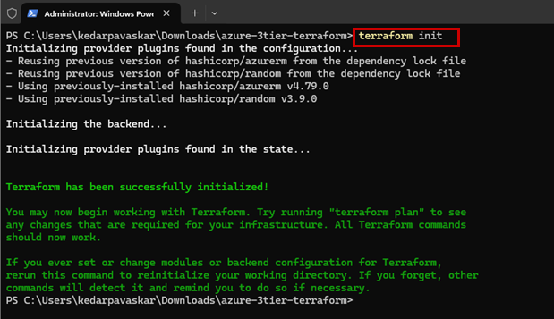
You should see “Terraform has been successfully initialized!” in green at the end. If you see red error text instead, copy the error and we can troubleshoot it together.

Step 9 — Preview What Will Be Built
This is a dry run — nothing gets created yet, it just shows you what would happen:
terraform plan
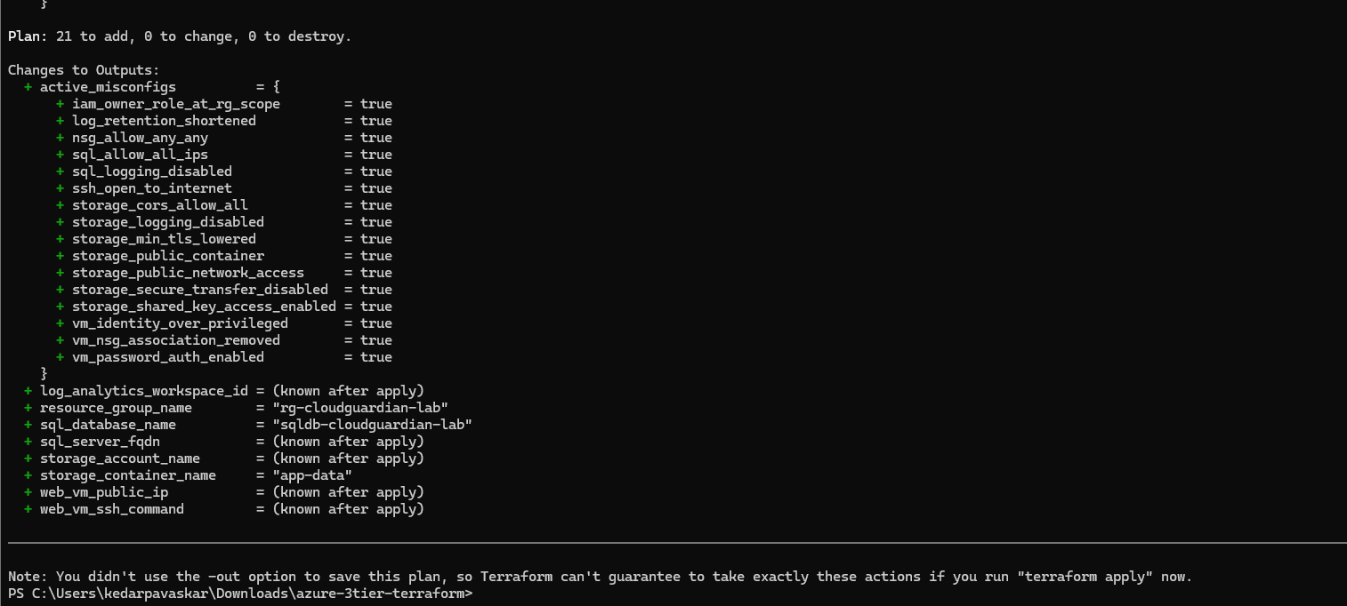
You can see a large output, Scroll up through the output. At the very bottom it should say something like “Plan: 19 to add, 0 to change, 0 to destroy.” That’s normal and expected — it’s listing every resource from Files 5–9 that it’s about to create. (The two new role-assignment resources in File 11 are defined with count = 0 at the secure baseline, so they show up as “0 to add” — not absent, just not created yet.)

Step 10 — Build It for Real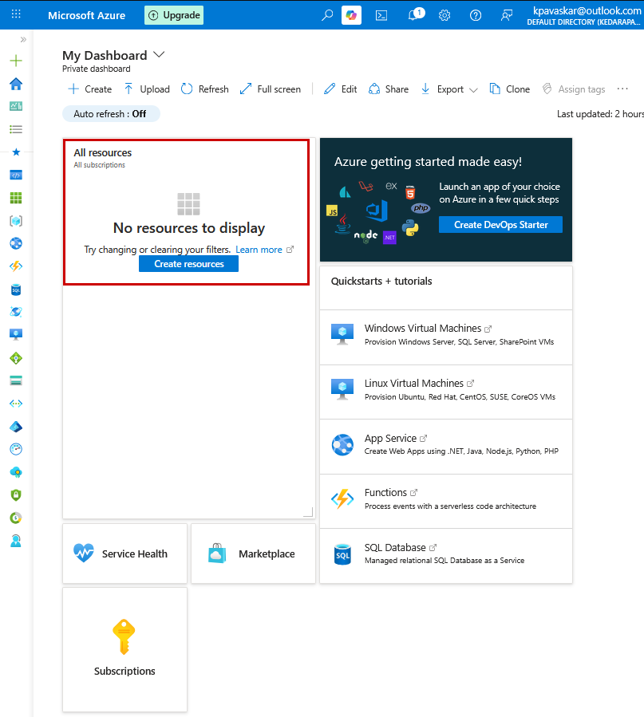

terraform apply
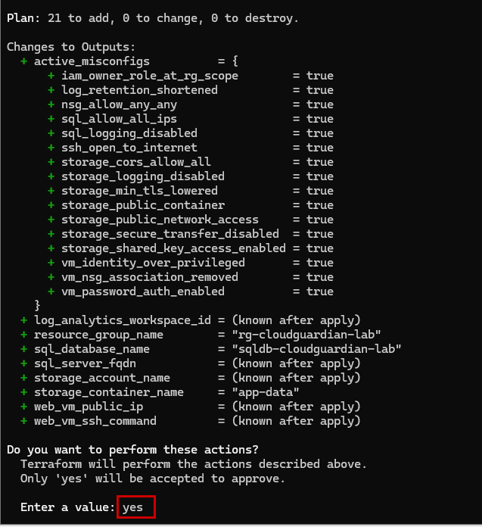It will show you the same plan again and then ask:
Do you want to perform these actions? Terraform will perform the actions described above. Only 'yes' will be accepted to approve. Enter a value:
Type yes and press Enter.
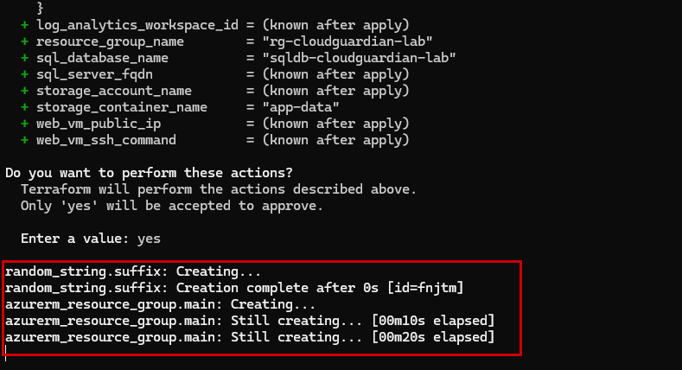
You can notice the Resources start to deploy.
This takes 5–10 minutes (the VM and SQL database are the slowest part). Don’t close the window — let it finish. When it’s done, you’ll see “Apply complete!” followed by the Outputs from File 10.
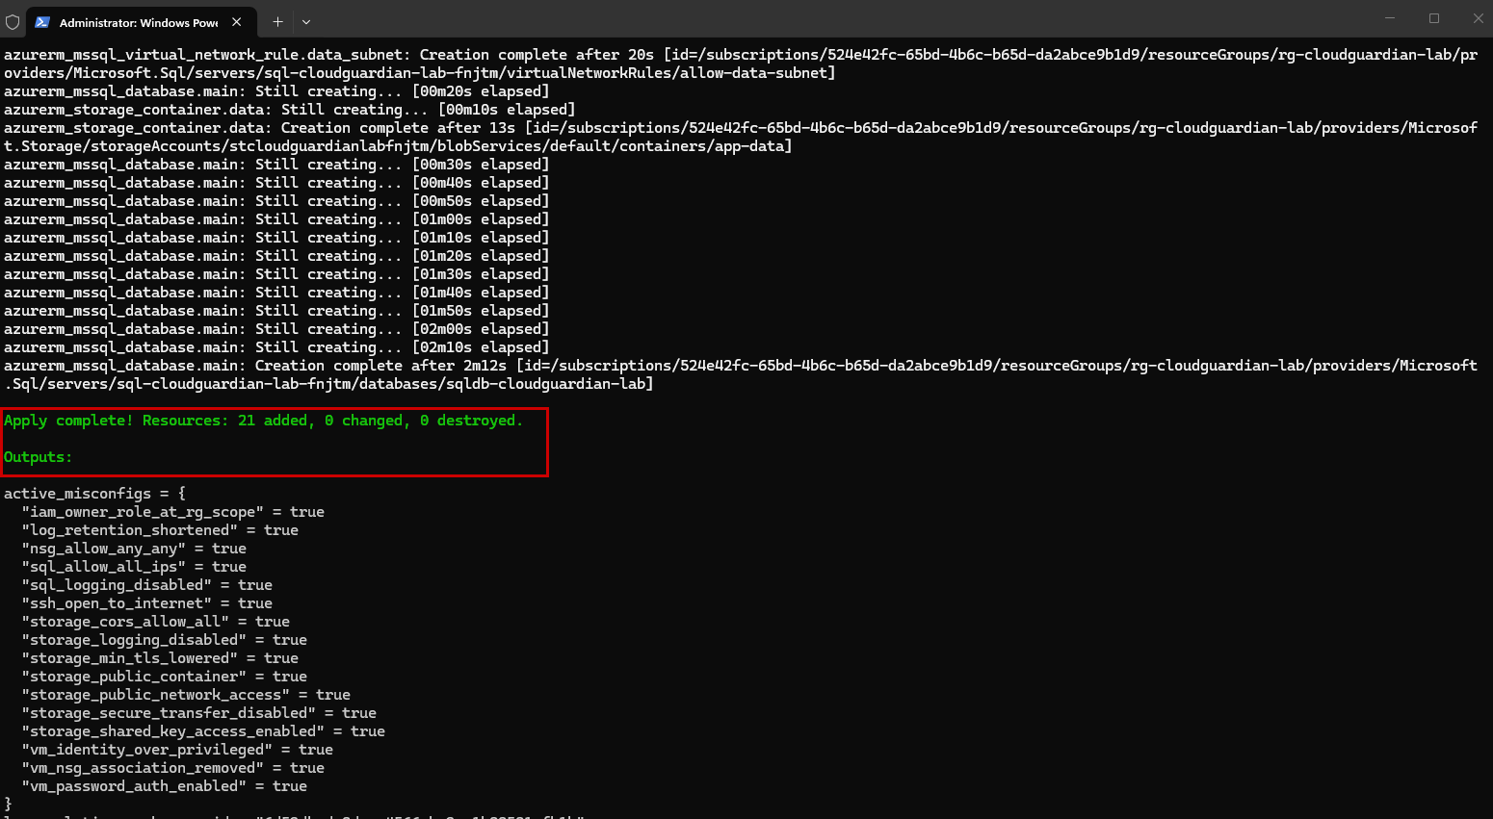
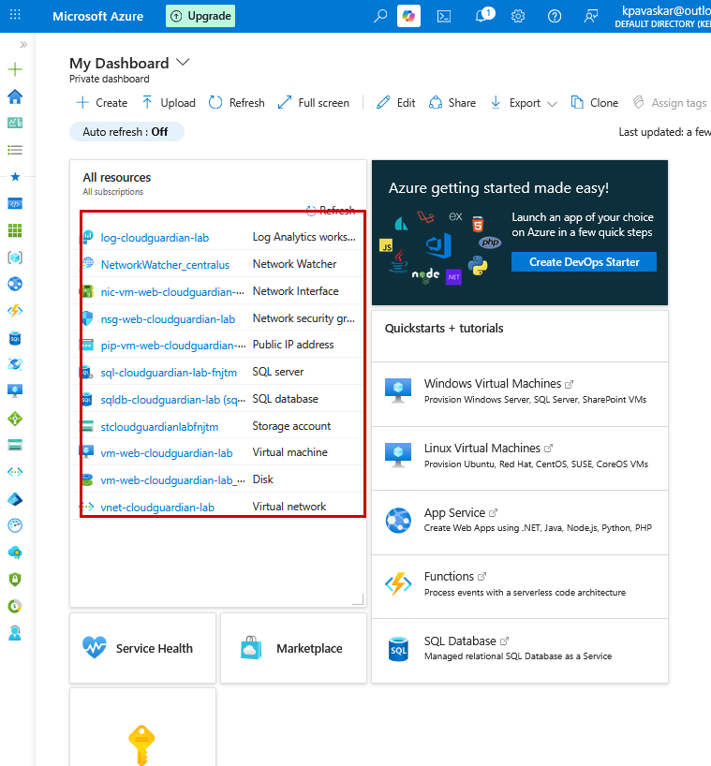
Notice a Series of Resources deployed on your Azure Tenant, now that the deploy is completed.

Step 11 — Confirm It Actually Worked
Check the Azure Portal: go to portal.azure.com → search “Resource groups” → open rg-cloudguardian-lab. You should see your VNet, VM, SQL server/database, storage account, and Log Analytics workspace all sitting there.
Check the web tier responds: copy the IP from terraform output web_vm_public_ip and paste it into a browser — you should see a simple “CloudGuardian web tier” page.
Check you can SSH in (optional):
terraform output web_vm_ssh_command
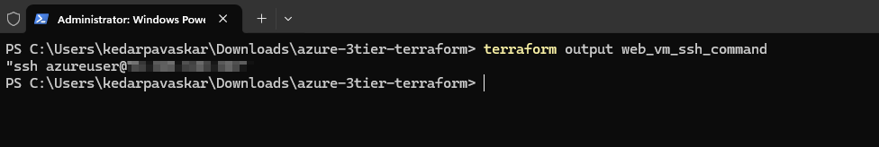
Copy the command it prints and run it — you should log into the VM without being asked for a password (key-based login working as intended).

Step 12 — Document Your Baseline Security Posture with Prowler (Week 1, Task 2)
This is the capstone’s “document the baseline posture using Prowler” task. Do this now, while everything in terraform.tfvars is still at its secure defaults — every misconfig_... line still commented out. This scan becomes your “before” snapshot; Step 13 produces the “after.”

12a. Install Prowler
In the same PowerShell window (Terraform doesn’t need to be running for this):
python -m pip install --user pipx
python -m pipx ensurepath
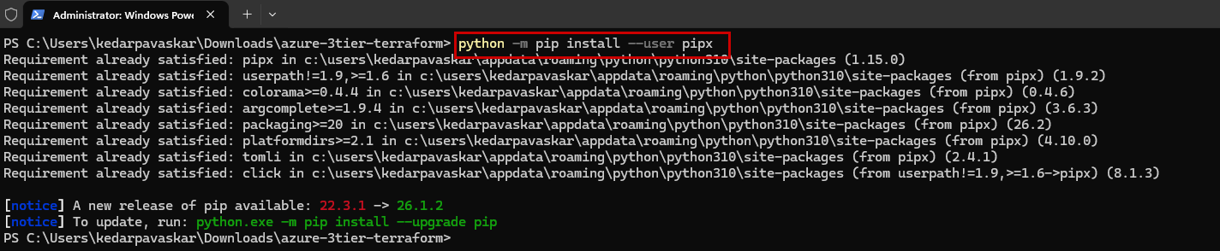
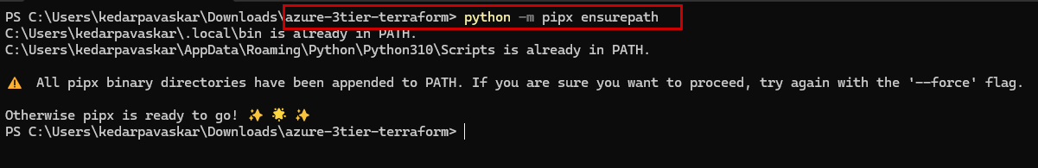
Upgrade the Close and reopen PowerShell so the PATH change takes effect, then:
pipx install prowler
prowler -v
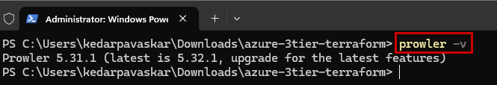
You should see a version number print back. If “prowler” isn’t recognized, close PowerShell completely and reopen it — same PATH-refresh fix as Step 1.
Mac/Linux: the same three commands work as-is, just from Terminal instead of PowerShell.

12b. Confirm you’re still logged into Azure
Prowler reuses the same Azure CLI session Terraform has been using — no separate password or key needed.
az account show --output table
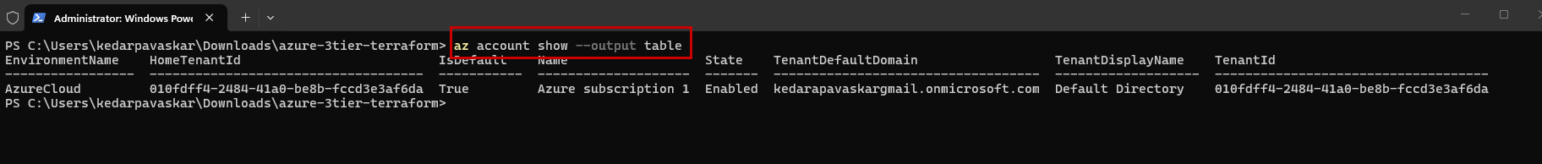If this fails or shows the wrong subscription, log back in the way that’s worked for you before:
az login --use-device-code
then complete the sign-in at https://microsoft.com/devicelogin.

12c. Run the baseline scan
New-Item -ItemType Directory -Force -Path "$env:USERPROFILE\cloudguardian-baseline"
prowler azure --az-cli-auth --output-formats csv json-ocsf html --output-directory "$env:USERPROFILE\cloudguardian-baseline"
Mac/Linux: replace the output path with something like ~/cloudguardian-baseline
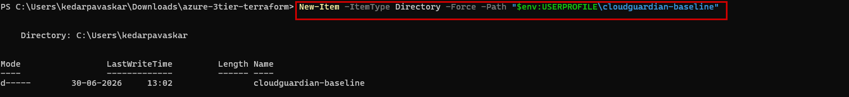
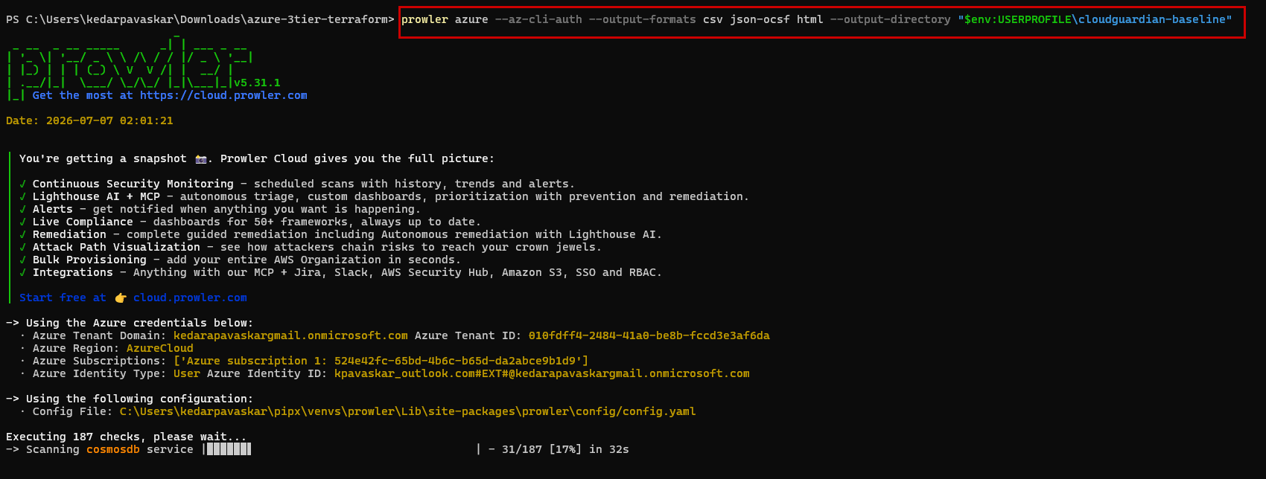
What each part means:
- --az-cli-auth — use your existing az login session, no extra setup
- -M csv json html — generate all three report formats in one run
- -o ... — the folder where the reports get saved
This checks Azure AD, networking, storage, SQL, your VM, and logging across the subscription — expect it to take a few minutes.
Post successful completion, It shall create Baseline Reports in the selected location.
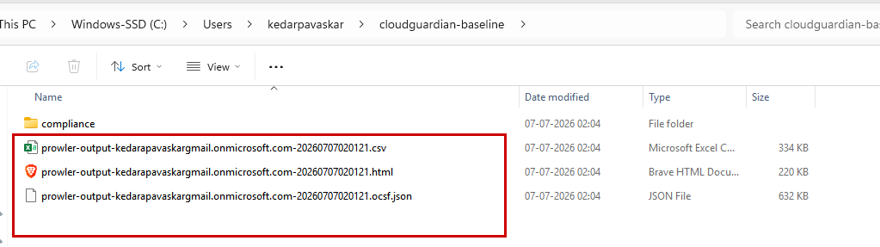

12d. What to expect on a free/student subscription
Some Azure AD–level checks will likely come back as errors or “MANUAL” rather than pass/fail — that’s expected, not something broken. A free/student account doesn’t carry full Global Admin permissions, the same RBAC constraint you’ve already run into with Terraform provider registration. Note this rather than trying to fix it:
Report line you can reuse: “Certain Azure AD-tier checks were not assessable due to subscription RBAC limits on the free/student tenant; subscription-scope checks (storage, networking, SQL, logging) completed normally.”

12e. Save the baseline report
Open the .html file from your output folder in a browser — it gives a clean pass/fail dashboard per check. This file is your Week 1 baseline Prowler report deliverable. Keep it; you’ll compare against it after Step 13.

Step 13 — Introduce the Controlled Misconfiguration Set (Week 1, Task 3)
This is the capstone’s third Week 1 task: “introduce a controlled set of misconfigurations across IAM, storage, networking, encryption, and logging.” The project ships with eighteen toggles in total — the original six, plus twelve added specifically to cover IAM and Encryption properly and round out Networking, Storage, and Logging. That comfortably clears the rubric’s minimum of 8 (individual) or 12+ (team), with margin to spare.

Open the Terraform.Tfvars file and uncomment the misconfigurations, perform a Terraform Apply.
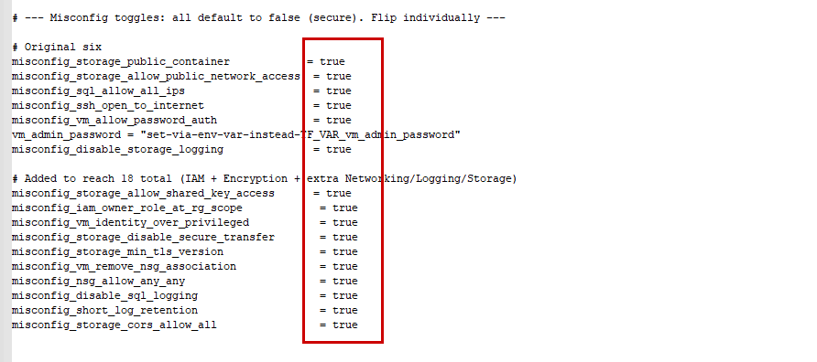

13b. The eighteen misconfigurations in this project
Toggle (in terraform.tfvars) | Category | What it actually changes
misconfig_storage_public_container | Storage | Blob container becomes world-readable (anonymous public read)
misconfig_storage_allow_public_network_access | Storage / Networking | Storage account accepts traffic from any network, not just allow-listed ones
misconfig_sql_allow_all_ips | Networking / Database | SQL firewall rule opens the entire internet (0.0.0.0–255.255.255.255)
misconfig_ssh_open_to_internet | Networking | NSG SSH rule changes from “my IP only” to “any IP”
misconfig_vm_allow_password_auth | IAM / Authentication | VM accepts password login in addition to SSH key
misconfig_disable_storage_logging | Logging | Storage diagnostic-settings wiring to Log Analytics is skipped entirely
misconfig_storage_allow_shared_key_access | IAM | Storage account defaults to Shared Key auth in Portal/tools instead of Microsoft Entra ID
misconfig_iam_owner_role_at_rg_scope | IAM | Owner role (not a scoped role) assigned to the deploying identity at Resource Group scope
misconfig_vm_identity_over_privileged | IAM | Web VM’s managed identity granted Contributor at the whole subscription scope
misconfig_storage_disable_secure_transfer | Encryption | Storage account reachable over plain HTTP, not HTTPS-only
misconfig_storage_min_tls_version | Encryption | Storage account’s minimum TLS lowered to TLS1_0
misconfig_sql_disable_tde | Encryption | Transparent Data Encryption turned off on the SQL database
misconfig_sql_min_tls_version | Encryption | SQL server’s minimum TLS lowered to 1.0
misconfig_vm_remove_nsg_association | Networking | NSG detached from the web subnet entirely — no firewall at all
misconfig_nsg_allow_any_any | Networking | Adds a standalone rule allowing any protocol/port from any source
misconfig_disable_sql_logging | Logging | SQL diagnostic setting skipped, independently of the storage logging toggle
misconfig_short_log_retention | Logging | Log Analytics retention shortened from 30 days to 7
misconfig_storage_cors_allow_all | Storage | Storage account CORS rules allow any origin and any method
Heads-up on misconfig_iam_owner_role_at_rg_scope and misconfig_vm_identity_over_privileged specifically: both create a real Azure role assignment, which needs Microsoft.Authorization/roleAssignments/write permission. On a free/student subscription you’re normally the subscription’s Owner already, so this should just work — but if apply fails with AuthorizationFailed on either one, document that same misconfig manually instead (Portal → Resource Group → Access control (IAM) → Add role assignment), the same way you’ve already handled Prowler’s AAD-level check failures.

13c. Recommended workflow: one toggle at a time, with evidence
Going one at a time is slower but gives you a clean, defensible misconfig catalogue — each entry backed by a specific Prowler finding, which is exactly what the rubric’s “misconfig detection” and “report + oral defense” criteria reward. With eighteen toggles this takes a while end to end; it’s fine to batch a few from the same category (e.g. the three Encryption ones) into one apply if you’d rather move faster, as long as you can still tell from the Portal/Prowler which finding came from which toggle.
- Open terraform.tfvars and uncomment one (or a same-category few) misconfig_... line(s), setting them to true.
- Save the file, then run terraform apply and type yes. Only those resources change; everything else stays untouched.
- Verify the change actually took effect in the Azure Portal (open the relevant resource and check the setting directly).
- Re-run Prowler, pointing at a new output folder so you don’t overwrite the last one:
prowler azure --az-cli-auth -M csv json html -o $env:USERPROFILE\cloudguardian-after-<toggle-name>
- Compare against your Step 12 baseline report: find the specific check that flipped from PASS to FAIL. That check ID/title is your evidence.
- Add a row to your misconfig catalogue (template below), then move to the next toggle and repeat.

13d. Misconfig catalogue template
A table like this, filled in as you go, becomes the “misconfig catalogue with rationale” deliverable for your report:
Toggle | Category | Prowler check that flipped | Risk rationale (1–2 lines)
misconfig_ssh_open_to_internet | Networking | (fill in after Step 13c)
misconfig_vm_allow_password_auth | IAM / Auth
misconfig_sql_allow_all_ips | Networking / DB
misconfig_storage_public_container | Storage
misconfig_storage_allow_public_network_access | Storage
misconfig_disable_storage_logging | Logging
misconfig_storage_allow_shared_key_access | IAM
misconfig_iam_owner_role_at_rg_scope | IAM
misconfig_vm_identity_over_privileged | IAM
misconfig_storage_disable_secure_transfer | Encryption
misconfig_storage_min_tls_version | Encryption
misconfig_sql_disable_tde | Encryption
misconfig_sql_min_tls_version | Encryption
misconfig_vm_remove_nsg_association | Networking
misconfig_nsg_allow_any_any | Networking
misconfig_disable_sql_logging | Logging
misconfig_short_log_retention | Logging
misconfig_storage_cors_allow_all | Storage

13e. Get the clean summary
Once you’ve worked through the toggles you want active, run:
terraform output active_misconfigs

New-Item -ItemType Directory -Force -Path "$env:USERPROFILE\cloudguardian-afterIntroducting-misconfigs"

prowler azure --az-cli-auth --output-formats csv json-ocsf html --output-directory "$env:USERPROFILE\cloudguardian-afterIntroducting-misconfigs"

This prints the true/false table built into outputs.tf — a tidy appendix item for your report.

13f. Optional: one consolidated “fully misconfigured” Prowler run
After you’ve catalogued each toggle individually, you can also leave all of them switched on and run one final Prowler scan over the whole environment:

function New-CloudGuardianCatalogue {
param(
[Parameter(Mandatory=$true)]
[string]$ProwlerCsvPath,
[string]$OutputDir = "$env:USERPROFILE\CloudGuardian-Catalogue"
)

# Accept either a folder (auto-picks newest .csv) or a direct file path
if (Test-Path $ProwlerCsvPath -PathType Container) {
$csvFile = Get-ChildItem -Path $ProwlerCsvPath -Filter "*.csv" |
Sort-Object LastWriteTime -Descending | Select-Object -First 1
if (-not $csvFile) { Write-Error "No .csv file found in $ProwlerCsvPath"; return }
$ProwlerCsvPath = $csvFile.FullName
}
if (-not (Test-Path $ProwlerCsvPath)) { Write-Error "File not found: $ProwlerCsvPath"; return }

New-Item -ItemType Directory -Force -Path $OutputDir | Out-Null

# Prowler CSVs are semicolon-delimited; auto-detect just in case
$firstLine = Get-Content -Path $ProwlerCsvPath -TotalCount 1
$semiCount = ($firstLine.ToCharArray() | Where-Object { $_ -eq ';' }).Count
$commaCount = ($firstLine.ToCharArray() | Where-Object { $_ -eq ',' }).Count
$delimiter = if ($semiCount -gt $commaCount) { ';' } else { ',' }

$findings = Import-Csv -Path $ProwlerCsvPath -Delimiter $delimiter

if (-not ($findings | Get-Member -Name "STATUS" -ErrorAction SilentlyContinue)) {
Write-Error "The CSV didn't parse with the expected Prowler columns. Open it in Notepad and check whether fields are separated by ';' or ',' — then let me know and I'll adjust."
return
}

$failRows = $findings | Where-Object { $_.STATUS -eq 'FAIL' }
Write-Host "Loaded $($findings.Count) findings ($($failRows.Count) FAIL) using delimiter '$delimiter'" -ForegroundColor Cyan

# 16 toggles — matches the final deployed Terraform (misconfig_sql_disable_tde
# and misconfig_sql_min_tls_version were removed: Azure no longer permits
# either at the platform level, regardless of provider settings).
$catalogueDefs = @(
@{ Toggle="misconfig_storage_public_container"; Category="Storage"; ResourcePattern="storage|^st"; CheckPattern="container.*(public|anonymous)|anonymous.*(access|read)|public.*blob"; Rationale="Anyone on the internet can read or download blob contents without authentication, risking exposure of sensitive application data." }
@{ Toggle="misconfig_storage_allow_public_network_access"; Category="Storage / Networking"; ResourcePattern="storage|^st"; CheckPattern="network.*(rule|access)|public network access|firewall"; Rationale="Removes network-level restrictions entirely, letting the storage account be reached from any IP rather than only trusted/allow-listed networks." }
@{ Toggle="misconfig_sql_allow_all_ips"; Category="Networking / Database"; ResourcePattern="sql"; CheckPattern="firewall.*rule|allow.*all|0\.0\.0\.0"; Rationale="The database is reachable from any IP address on the internet, turning a firewall control into a no-op and exposing it to brute-force/credential-stuffing attempts." }
@{ Toggle="misconfig_ssh_open_to_internet"; Category="Networking"; ResourcePattern="nsg-web|vm-web"; CheckPattern="ssh|port.*22|22.*open"; Rationale="Management access (SSH) is exposed to the entire internet instead of a single trusted IP, significantly increasing the attack surface for credential or key compromise attempts." }
@{ Toggle="misconfig_vm_allow_password_auth"; Category="IAM / Authentication"; ResourcePattern="vm-web"; CheckPattern="password.*auth|ssh.*key"; Rationale="Allows password-based SSH login alongside key-based auth, reintroducing a weaker, brute-forceable authentication method on the host." }
@{ Toggle="misconfig_disable_storage_logging"; Category="Logging"; ResourcePattern="storage|^st"; CheckPattern="logging|diagnostic|monitor"; Rationale="No audit trail is generated for reads/writes/deletes against the storage account, undermining incident detection and forensic investigation." }
@{ Toggle="misconfig_storage_allow_shared_key_access"; Category="IAM"; ResourcePattern="storage|^st"; CheckPattern="shared key|oauth|azure ad author"; Rationale="Defaults to long-lived account-key authentication instead of per-identity Azure AD access, making access harder to audit, scope, or revoke individually." }
@{ Toggle="misconfig_iam_owner_role_at_rg_scope"; Category="IAM"; ResourcePattern="rg-cloudguardian|subscriptions"; CheckPattern="owner|excessive.*permission|role.*assign"; Rationale="Grants full administrative control (Owner) over every resource in the group instead of the minimum role needed, violating least-privilege and widening blast radius if the identity is compromised." }
@{ Toggle="misconfig_vm_identity_over_privileged"; Category="IAM"; ResourcePattern="vm-web|subscriptions"; CheckPattern="owner|contributor|excessive.*permission|managed identity"; Rationale="The web VM's own identity can modify or delete resources anywhere in the subscription — if the VM is compromised, the attacker inherits subscription-wide control." }
@{ Toggle="misconfig_storage_disable_secure_transfer"; Category="Encryption"; ResourcePattern="storage|^st"; CheckPattern="secure transfer|https.*only|http.*traffic"; Rationale="Permits unencrypted HTTP connections to the storage account, exposing data (and any credentials in transit) to interception." }
@{ Toggle="misconfig_storage_min_tls_version"; Category="Encryption"; ResourcePattern="storage|^st"; CheckPattern="tls.*version|minimum tls"; Rationale="Allows clients to connect using TLS 1.0, a deprecated protocol version with known cryptographic weaknesses." }
@{ Toggle="misconfig_vm_remove_nsg_association"; Category="Networking"; ResourcePattern="snet-web|nsg-web|subnet"; CheckPattern="network security group|nsg.*associat|subnet.*nsg"; Rationale="The subnet has no network security group at all, removing every inbound/outbound filtering rule and leaving the web tier fully exposed at the network layer." }
@{ Toggle="misconfig_nsg_allow_any_any"; Category="Networking"; ResourcePattern="nsg-web"; CheckPattern="any.*any|unrestricted|0\.0\.0\.0.*\*"; Rationale="A single rule permits all protocols and ports from any source, functionally disabling the firewall regardless of the other rules in place." }
@{ Toggle="misconfig_disable_sql_logging"; Category="Logging"; ResourcePattern="sql"; CheckPattern="audit|diagnostic|logging"; Rationale="No diagnostic logs are captured for the SQL database, removing visibility into queries, errors, and potential abuse independent of the storage tier." }
@{ Toggle="misconfig_short_log_retention"; Category="Logging"; ResourcePattern="log-cloudguardian|loganalytics|workspace"; CheckPattern="retention"; Rationale="Reduces the investigation window from 90 days down to Azure's allowed minimum of 30, risking loss of evidence for incidents discovered after the first month." }
@{ Toggle="misconfig_storage_cors_allow_all"; Category="Storage"; ResourcePattern="storage|^st"; CheckPattern="cors"; Rationale="Allows any website to make cross-origin requests to the storage account, which can be abused for data exfiltration or client-side attacks against users of the storage account." }
)

$catalogue = foreach ($def in $catalogueDefs) {
$resourceMatches = $failRows | Where-Object { $_.RESOURCE_NAME -match $def.ResourcePattern -or $_.RESOURCE_UID -match $def.ResourcePattern }
$bestMatches = $resourceMatches | Where-Object { $_.CHECK_TITLE -match $def.CheckPattern -or $_.CHECK_ID -match $def.CheckPattern }

if ($bestMatches) {
$checkText = ($bestMatches | Select-Object -First 2 | ForEach-Object { "$($_.CHECK_ID): $($_.CHECK_TITLE)" }) -join " | "
} elseif ($resourceMatches) {
$candidates = ($resourceMatches | Select-Object -First 3 -ExpandProperty CHECK_TITLE) -join " | "
$checkText = "Review needed - candidate FAIL findings on this resource: $candidates"
} else {
$checkText = "Not auto-matched - verify manually in the HTML report"
}

[PSCustomObject]@{
Toggle = $def.Toggle
Category = $def.Category
"Prowler check that flipped" = $checkText
"Risk rationale" = $def.Rationale
}
}

# --- CSV ---
$csvOut = Join-Path $OutputDir "CloudGuardian_Misconfig_Catalogue.csv"
$catalogue | Export-Csv -Path $csvOut -NoTypeInformation -Encoding UTF8

# --- HTML ---
$htmlOut = Join-Path $OutputDir "CloudGuardian_Misconfig_Catalogue.html"
$style = @"
<style>
body { font-family: Arial, sans-serif; margin: 30px; }
h1 { color: #1F4E79; }
table { border-collapse: collapse; width: 100%; }
th { background-color: #1F4E79; color: white; padding: 8px; text-align: left; }
td { border: 1px solid #ccc; padding: 8px; vertical-align: top; }
tr:nth-child(even) { background-color: #f7f9fb; }
</style>
"@
$catalogue | ConvertTo-Html -Title "CloudGuardian Misconfig Catalogue" `
-PreContent "<h1>CloudGuardian - Misconfiguration Catalogue</h1>" -Head $style |
Out-File -FilePath $htmlOut -Encoding UTF8

Write-Host "CSV saved: $csvOut" -ForegroundColor Green
Write-Host "HTML saved: $htmlOut" -ForegroundColor Green

# --- DOCX via Word COM automation ---
$docxOut = Join-Path $OutputDir "CloudGuardian_Misconfig_Catalogue.docx"
try {
$word = New-Object -ComObject Word.Application
$word.Visible = $false
$doc = $word.Documents.Add()

$titlePara = $doc.Content.Paragraphs.Add()
$titlePara.Range.Text = "CloudGuardian - Misconfiguration Catalogue"
$titlePara.Range.Font.Size = 18
$titlePara.Range.Font.Bold = $true
$titlePara.Range.InsertParagraphAfter()

$rows = $catalogue.Count + 1
$tableRange = $doc.Content
$tableRange.Collapse(0) # wdCollapseEnd
$table = $doc.Tables.Add($tableRange, $rows, 4)
$table.Borders.Enable = $true
$table.AutoFitBehavior(2) # wdAutoFitWindow

$headers = @("Toggle", "Category", "Prowler check that flipped", "Risk rationale (1-2 lines)")
for ($c = 1; $c -le 4; $c++) {
$table.Cell(1, $c).Range.Text = $headers[$c - 1]
$table.Cell(1, $c).Range.Font.Bold = $true
}

$r = 2
foreach ($row in $catalogue) {
$table.Cell($r, 1).Range.Text = $row.Toggle
$table.Cell($r, 2).Range.Text = $row.Category
$table.Cell($r, 3).Range.Text = $row."Prowler check that flipped"
$table.Cell($r, 4).Range.Text = $row."Risk rationale"
$r++
}

$doc.SaveAs([ref]$docxOut, [ref]12) # 12 = wdFormatXMLDocument (.docx)
$doc.Close()
$word.Quit()
[System.Runtime.InteropServices.Marshal]::ReleaseComObject($word) | Out-Null
[GC]::Collect()
[GC]::WaitForPendingFinalizers()

Write-Host "DOCX saved: $docxOut" -ForegroundColor Green
} catch {
Write-Warning "Could not generate the Word document automatically (Microsoft Word may not be installed). CSV and HTML were still created. Error: $($_.Exception.Message)"
}

Write-Host "`nDone. Open the files and fill in any 'Review needed' / 'Not auto-matched' rows by hand from the HTML report before submitting." -ForegroundColor Yellow
}

This will now Produce all the reports related to the Misconfigs that were introduced and the risk rationale behind the same.
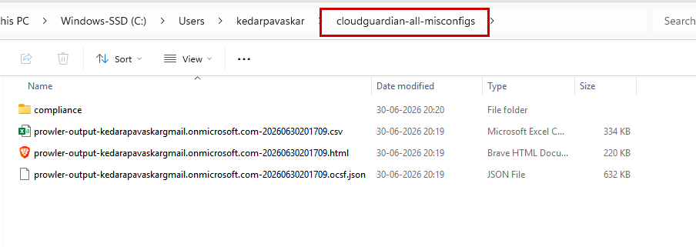
This consolidated report is a useful head start for Week 2 (Detect & Prioritize), where you’ll normalize and prioritize findings across tools.

Step 14 — Shut It Down When You’re Done for the Day
This step matters for cost control. The VM and SQL database cost a small amount per hour even sitting idle — don’t leave this running overnight unless you’re actively using your free credit on purpose.
terraform destroy
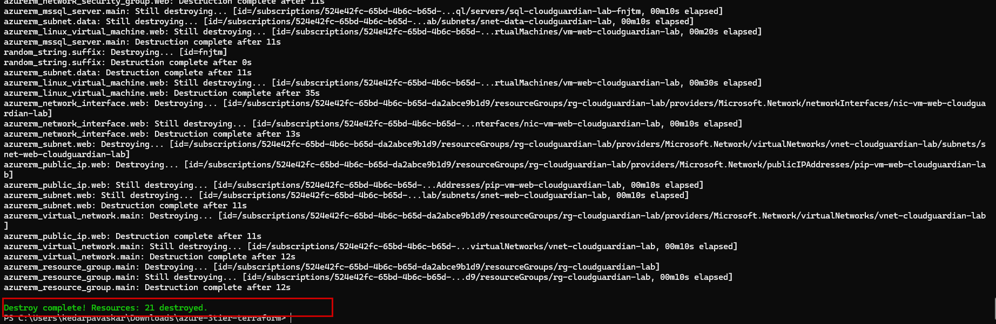Type yes when prompted. This removes everything Terraform created. Your terraform.tfvars and code stay on your laptop, so running terraform apply again later rebuilds the exact same environment in a few minutes.

Troubleshooting Common Errors
Error message contains... | What it means | Fix
is not recognized as the name of a cmdlet | PowerShell can’t find az, terraform, or prowler | Close and reopen PowerShell; if it persists, the install didn’t add it to PATH — see Step 1 / Step 12a notes
The storage account named ... is already taken | Storage account names must be unique across all of Azure, not just your account | Edit project_name in terraform.tfvars to something more unique (e.g. add your initials) and re-apply
Authorization failed / does not have authorization to perform action | Your account doesn’t have permission, or you’re on the wrong subscription | Re-check az account show; make sure you’re on your own free subscription, not a shared/work one
MissingSubscriptionRegistration | Azure hasn’t “turned on” a resource type for your subscription yet | Run az provider register --namespace Microsoft.Sql (swap in the namespace named in the error), wait 1–2 minutes, re-apply
SSH connection times out / refused | Your public IP changed since Step 4, or the misconfig SSH toggle reverted | Re-check ifconfig.me, update my_ip_cidr in terraform.tfvars, re-run terraform apply
QuotaExceeded or SkuNotAvailable | The free account doesn’t have quota for that VM size/region | Try a different location in terraform.tfvars (e.g. “East US” instead of “Central India”)
Password prompt when SSHing in (shouldn’t happen by default) | You may have flipped misconfig_vm_allow_password_auth on | That’s expected if you did it on purpose; otherwise check terraform.tfvars
Prowler finishes but most Azure AD checks show ERROR/MANUAL | Free/student subscriptions don’t carry full Global Admin / AAD permissions | Expected on this tier — note it in your report (see Step 12d) rather than troubleshooting it as a bug
prowler: command not found (right after pipx install prowler) | PATH wasn’t refreshed after pipx ensurepath | Close PowerShell completely and reopen a fresh window, then retry prowler -v
If you hit something not on this list, copy the full red error text from PowerShell and paste it into the chat — that’s usually enough to diagnose immediately.

Quick Command Cheat Sheet
Command | What it does
az login | connect your computer to Azure
az login --use-device-code | fallback sign-in when MFA blocks the normal browser login
terraform init | one-time setup per folder (reads all the .tf files)
terraform plan | preview changes (safe, makes nothing)
terraform apply | actually build/update things
terraform output | see useful values (IPs, names) after apply
terraform output active_misconfigs | see which misconfig toggles are on
terraform destroy | tear everything down (do this to save cost)
pipx install prowler | install Prowler (one-time)
prowler azure --az-cli-auth | run a Prowler scan against Azure using your az login session
prowler azure --az-cli-auth -M csv json html -o <folder> | run a scan and save CSV + JSON + HTML reports to <folder>

